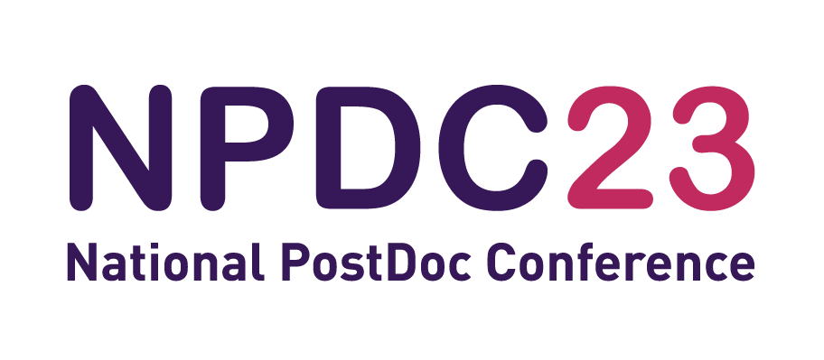

SELF REFLECTION
What have you learned from NPDC23?
Were any of your existing views changed or challenged?
What key strengths did you uncover?
What areas of development have you missed?
Please type here.

What are you going to change in the short term?
Is there anything you can do differently starting tomorrow?
What specific actions will you take to apply or follow up your learning?
Please type here.

What do you hope to change in the next 3 months?
What do you hope to be doing differently in 3 months time?
What steps will you take to achieve them?
How can other help you reach those aims?
Please type here.

